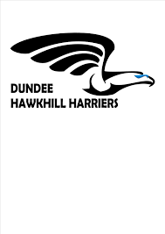
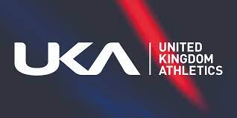

CODE OF CONDUCT: CHILDREN AND YOUNG PEOPLE (under 18 years)
As a child or young person under 18 years, I have the right to:
• be safe and protected
• be listened to
• be respected and treated fairly
• be believed
• ask for help
• be coached by someone who has the right qualifications.

As a young athlete, I will respect the code of conduct and I will:
• be friendly and supportive to other athletes
• keep myself safe
• tell my coach if I am ill or injured
• report inappropriate behaviour or risky situations to an adult
• compete fairly and respect other athletes and officials
• respect the rules of my club
• behave and listen to all instructions from my coach and officials
• take care of equipment owned or provided by the club or training facility
• not use bad language or take part in inappropriate or illegal behaviour
• not bully anyone or pressure them to do things they do not want to, including online
• in no way undermine, put down or belittle other athletes, coaches or practitioners
• keep to agreed timings for all club activities
• tell my parents/carers where I am or if I’m going to be late
• not use my mobile phone during training, competitions or in changing rooms
• not carry or consume alcohol or illegal substances while training or competing in athletics
• use safe transport or travel arrangements.

• I recognise that I am bound by the UKA Anti-Doping Regulations, and submit to the authority of UK Anti-Doping in the application and enforcement of the Anti-Doping Rules. UK Anti-Doping Rules apply to all member participating in athletics for a minimum of 12 months from the commencement of membership whether or not the member is a citizen of, or resident in, the UK. Any athlete wishing to retire from the sport of athletics must put this in writing to the club and their Home Country Athletics Federation (Athletics Northern Ireland / England Athletics / Scottish Athletics / Welsh Athletics) and cancel any applicable membership. Official retirement will remove the athlete from being under the auspices of UKA's Anti-Doping Rules.

BREACH OF THE CODE OF CONDUCT
I understand that if I do not follow the code, action can be taken by my club and I may:
• be asked to apologise for my behaviour
• receive a verbal warning from my coach
• receive a verbal or written warning from the club committee
• be suspended from attending club training sessions
• be suspended or required to leave the club.
Additionally, my club will always tell my parents/carers if I breach the code of conduct.
ATHLETE:
Name . . . . . . . . . . . . . . . . . . . . . . . . . . . . . . . Signature . . . . . . . . . .. . . . . . . . . .
Date . . . . . . . . . . .
PARENT/CARER:
Name . . . . . . . . . . . . . . . . . . . . . . . . . . . . . . . Signature . . . . .. . . . . . . . . . . . . . . . . .
Date . . . . . . . . .

