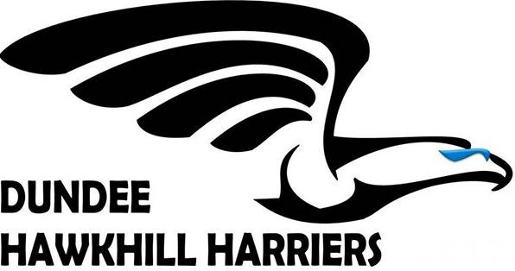
DHH Kit Order Form

Athlete Name

Ordered by (Name)
Email Address

Contact Telephone No.

Item Required | Colour (if App) | Size  (If App) | Personalised  Y or N | Quantity | Cost
 |  |  |  | TOTAL =

Personalisation Details …………………………………………………………………
(Please print clearly in block capitals as errors cannot to rectified)

Please return form to Ken Letham or email to kenletham@hotmail.com

Cash / Cheque / Bank Transfer acceptable. Contact Ken for Bank Details.

Sizing Guide: (Recommend trying on size prior to purchase if requiring personalisation)

Youths:

Size | YS (5-6yr) | YM (7-8yr) | YL (9-11yr) | YXL (12-13yr)
To Fit (Ins) | 26/28” | 30/32” | 34/36” | 36/38”
____________________________________________________________

Adult:

Men Size | XS | S | M | L | XL | 2XL
To Fit (Ins)  Ladies: | 35  8 | 38  10 | 40  12 | 43  14 | 45  16 | 48  18

